AMINO ACIDS
BEHAVIOUR OBJECTIVES
At the end of this lesson, students should be able to:
- mention 5 natural sources of amino acids.
- explain and illustrate proteins as a polymer of amino acids.
- enumerate and explain at least 5 physical and chemical properties of amino acids.
- illustrate the structure of proteins.
- outline at least 5 uses of amino acids.
- demonstrate the tests for amino acids.

Amino acids are organic compounds of carbon, hydrogen, oxygen and nitrogen. They are the basic structural units of proteins. Each amino acid contains an amino group (-NH₂) and a carboxyl group (-COOH) in its molecule. The general structure is CH(R)(NH₂)(COOH).

STRUCTURE OF AMINO ACID
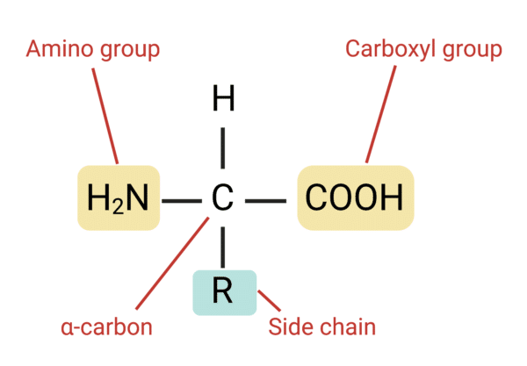
The carbon atom of the amino acid to which the functional groups are attached is called $∝$- carbon, and the R-group (side chain) attached to the $∝$ carbon determines the identity of the amino acids.
Examples of protein containing food are beef, fish, eggs, milk, cheese, beans, vegetables, and peas.

When two or more amino acids undergo condensation reaction, a string of covalently bonded amino acids is formed which is known as Peptide, linked by a chemical bond called peptide bond.When the amino acids are over 50, the longer chain is called polypeptide, and when the strings are arranged in sequential order, it is called Protein. Proteins are long chains of amino acids held together by peptide bonds. They are the products of successive condensation between carbonyl group of one amino acid and the amino group of another amino acid.
i.e. Monomer = Amino Acid, Polymer = Protein

FORMATION OF PROTEIN
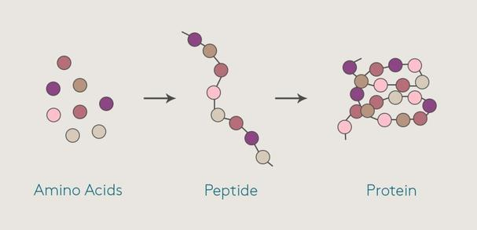

PHYSICAL PROPERTIES OF AMINO ACIDS/ PROTEINS
- Amino acids are colourless, crystalline solids with high melting and boiling points.
- Amino acids are more soluble in water than non-polar solvents .
- Amino acids decompose on heating at high temperature.
- Peptide bond formation.

CHEMICAL PROPERTIES OF AMINO ACIDS
- Amino acids react with alkanols in the presence of an acid catalyst (HCl) to give esters.
CH₃CH(NH₂).COOH + C₂H₅OH → [CH₃CH(NH₂)COOC₂H₅] +H₂O
- Amino acids react with sodium trioxocarbonate (IV) solution to liberate carbon (IV) oxide.
2NH₂(CH₂)COOH + Na₂CO₃ → 2NH₂(CH₂)COONa + H₂O + CO₂
- Amino acids react with dioxonitrate(III)acid to give nitrogen and the corresponding hydroxyl carboxylic acid.
NH₂(CH₂)COOH + HONO → CH₂(OH)COOH + N₂ + H₂O

USES OF AMINO ACIDS
- Helps to repair and build body tissues.
- It helps pH and body balance.
- It keeps the immune system strong.
- It drives metabolic reactions.

TEST FOR PROTEINS
- Biuret test: to a dilute egg white solution in a test tube, add 1cm³ of dilute caustic soda (NaOH), follows by few drops of copper(II)tetraoxosulphate(VI)-CuSO₄, shake after each drop. The formation of violet colouration indicates the presence of protein.
- Millon’s test: to an egg solution in a test tube, add few drops of millon’s reagent (a mixture and mercury and HNO₃). The formation of white precipitate which turns brick-red on heating confirms the presence of proteins.

DRILL QUESTIONS

- The type of bond that forms between amino acids in order to eventually from a protein is called?
- Hydrogen bond
- Ionic bond
- Peptide bond
- Hydrous bond

- Which monomers are proteins made from?
- Amino acids
- Fatty acids
- Fructose
- Glucose

- The chemicals used for testing for the presence of proteins include the following except?
- Millon’s reagent
- Fehling’s solution
- Concentrated HNO₃
- NaOH and CuSO₄

- Tri-peptide consists of ……………?
- 3 amino acids and 3 peptide bonds
- 2 amino acids and 3 peptide bonds
- 3 amino acids and 2 peptide bonds
- 3 amino acids and 4 peptide bonds

- The formation of peptide bond between two amino acids is an example of --------------- reaction.
- hydrolysis
- Condensation
- Decarboxylation
- Redox

ANSWER
- C
- A
- B
- C
- B

